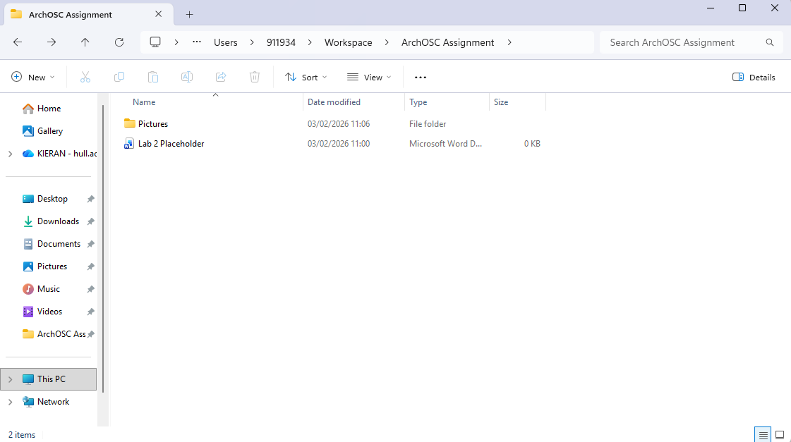Here I have created an assignment folder within my workspace, with a pictures folder within it.
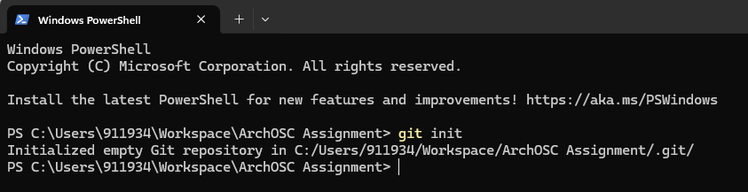Using the command line and the command ‘git init’, I have created a local git repository within my new folder.
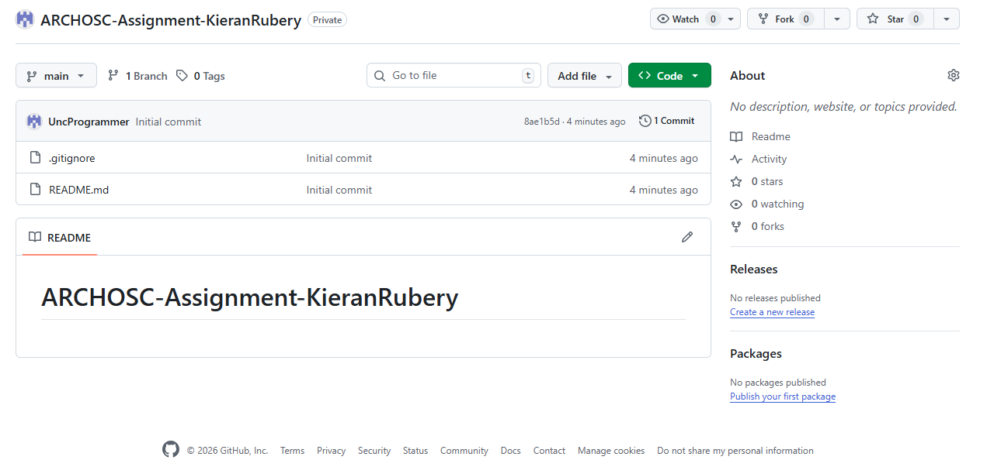A new online repository has been created on the Github website to match with the local repository.
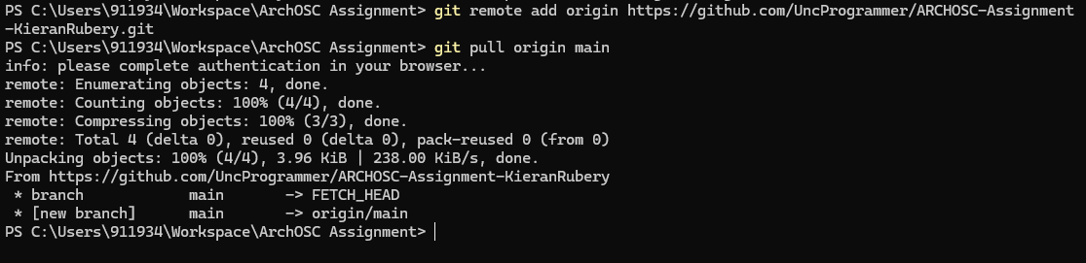Through a few commands, I linked the local repository to the online repository and made it a remote repository. ‘git remote add origin’ linked the two, while ‘git pull origin main’ pulled what was on the online repository and placed it in the local one.
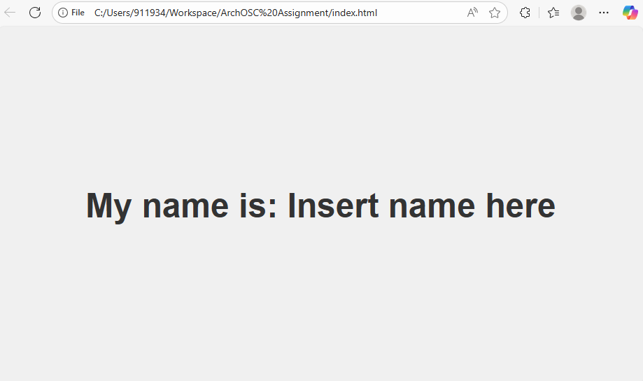Through adding an ‘index.html’ containing some HTML code, this website was created.

